**Differences between Reinforcement learning our agents use**

**Q learning table:**<https://danieltakeshi.github.io/2016/12/01/going-deeper-into-reinforcement-learning-understanding-dqn/>

**DQN table:**

Deep Q network is built on one simple layer of Q-network. In order to go from Q-Network to DQN we have to add:

1) Going from a single-layer network to a multi-layer convolutional network.

2) Implementing Experience Replay, which will allow our network to train itself using stored memories from it’s experience.

3) Utilizing a second “target” network, which we will use to compute target Q-values during our updates.

Reference and resources:

https://medium.com/emergent-future/simple-reinforcement-learning-with-tensorflow-part-6-partial-observability-and-deep-recurrent-q-68463e9aeefc

https://www.youtube.com/watch?v=9zhrxE5PQgY

https://colah.github.io/posts/2015-08-Understanding-LSTMs/

**Deep Belief Network:**

* A type of Unsupervised Pretrained Networks.
* a [generative](https://en.wikipedia.org/wiki/Generative_model) [graphical model](https://en.wikipedia.org/wiki/Graphical_model), or alternatively a class of [deep](https://en.wikipedia.org/wiki/Deep_learning) [neural network](https://en.wikipedia.org/wiki/Artificial_neural_network), composed of multiple layers of [latent variables](https://en.wikipedia.org/wiki/Latent_variables) ("hidden units"), with connections between the layers but not between units within each layer.
* When trained on a [set of examples](https://en.wikipedia.org/wiki/Training_set) [without supervision](https://en.wikipedia.org/wiki/Unsupervised_learning), a DBN can learn to probabilistically reconstruct its inputs. The layers then act as [feature detectors](https://en.wikipedia.org/wiki/Feature_learning). After this learning step, a DBN can be further trained with [supervision](https://en.wikipedia.org/wiki/Supervised_learning) to perform [classification](https://en.wikipedia.org/wiki/Statistical_classification).
* Two important aspects of Deep belief network is 1) Belief Net 2) RBM: Restricted Boltzmann Machine.
* They model the joint distribution between observed vector http://deeplearning.net/tutorial/_images/math/5fea02fa2a6372f999ae409954f23bba35f00b77.png and the ell hidden layers ^k as follows:
* 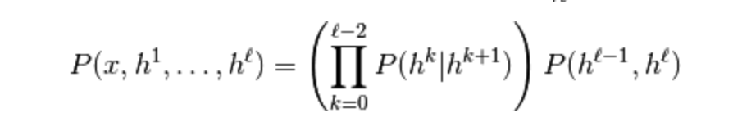
* Some resources: <http://deeplearning.net/tutorial/DBN.html>

[https://codeburst.io/deep-learning-deep-belief-network-fundamentals- d0dcfd80d7d4](https://codeburst.io/deep-learning-deep-belief-network-fundamentals-%20d0dcfd80d7d4)